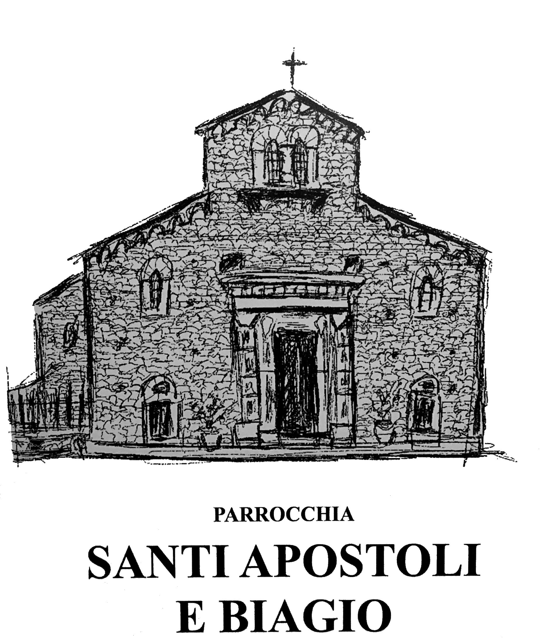

GODPARENT FOR BAPTISM/SPONSOR FOR CONFIRMATION ELIGIBILITY CERTIFICATE

Name of person to be Baptised/Confirmed: ___________________________________
Date of Baptism/Confirmation: _____________________________________________

Please read carefully and sign where indicated.

I hereby affirm that as the Baptism Godparent/Confirmation Sponsor of the above named Baptism/Confirmation Candidate the following applies:

“To be permitted to take on the function of sponsor a person must:
1. be designated by the one to be baptized, by the parents or the person who takes their place, or in their absence by the pastor or minister and have the aptitude and intention of fulfilling this function;
2. have completed the sixteenth year of age, unless the diocesan bishop has established another age, or the pastor or minister has granted an exception for a just cause;
3. be a Catholic who has been confirmed and has already received the most holy sacrament of the Eucharist and who leads a life of faith in keeping with the function to be taken on;
4. not be bound by any canonical penalty legitimately imposed or declared;
5. not be the father or mother of the one to be baptized.” (from Can. 874 §1)

I am not a part of organizations that are openly contrary to the Catholic Church.
I understand that being chosen as a Baptism Godparent/Confirmation Sponsor is a lifetime commitment to live and witness the Catholic way of life and to teach it to my godchild/confirmand to the best of my ability.

Confirmation Sponsor
Signature_____________________________________ Date__________________________

BAPTISM GODPARENT/CONFIRMATION SPONSOR CONTACT INFORMATION
Name (first and last) __________________________________________________________
Mailing Address ______________________________________________________________
City ____________________________State _____________ Zip Code __________________ Phone (Cell) _________________________Phone (Home) ___________________________
Email _________________________________________
Relationship to Confirmation Candidate (Parents are not eligible) ______________________
SACRAMENTAL HISTORY
Church of Baptism_________________________________
Date Baptised______________________ City,State, Country__________________________
Church of Confirmation ______________________________________
Date Confirmed ______________________ City, State, Country _______________________
If married, Church of Marriage __________________________
Date of Marriage _____________________ City, State, Country_______________________
Church where currently registered ___________________________________
Phone ___________________________ Address ________________________________
City ______________________________ State __________ Zip Code __________________

Parish Priest’s Signature (Required) __________________________________________
Date ________________________

